Assignment 8

12.1

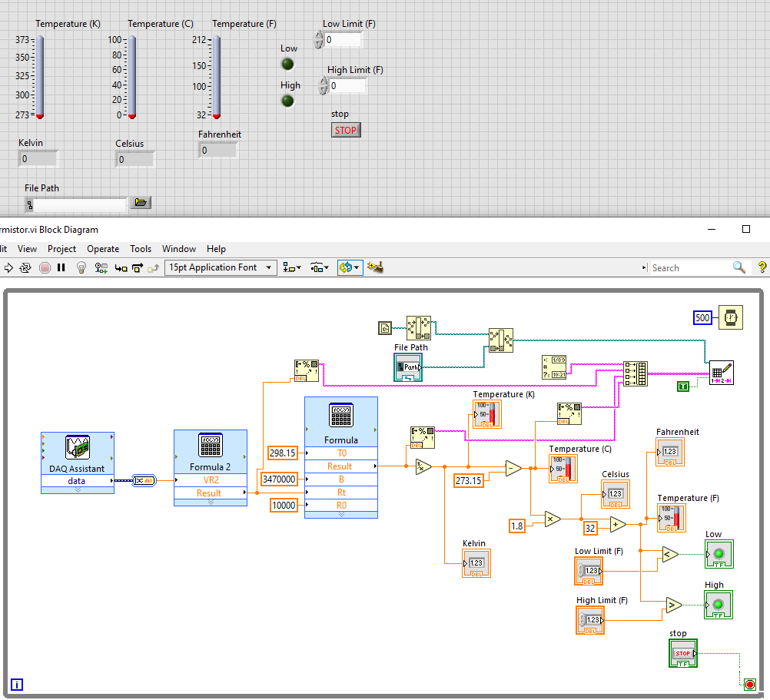

12.3

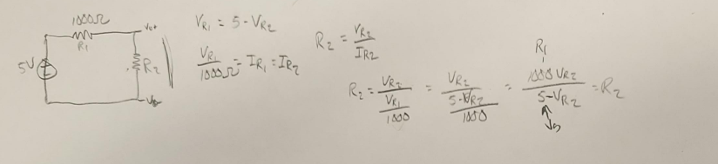

12.4

Time Resistance Voltage Temperature (C)

4:37 PM 7655.037339 0.003354 25.006846

4:37 PM 7655.037339 0.003354 25.006846

4:37 PM 7645.297738 0.003354 25.006878

4:37 PM 7640.436153 0.003354 25.006895

4:37 PM 7645.297738 0.003354 25.006878

4:37 PM 7630.729367 0.003354 25.006927

4:37 PM 7630.729367 0.003354 25.006927

4:37 PM 7630.729367 0.003354 25.006927

4:37 PM 7621.044367 0.003354 25.006960

4:37 PM 7625.884149 0.003354 25.006944

4:37 PM 7630.729367 0.003354 25.006927

4:37 PM 7630.729367 0.003354 25.006927

4:37 PM 7645.297738 0.003354 25.006878

4:37 PM 7645.297738 0.003354 25.006878

4:37 PM 7645.297738 0.003354 25.006878

13.1

